RC Circuit AC analysis
Via LTspice simulation
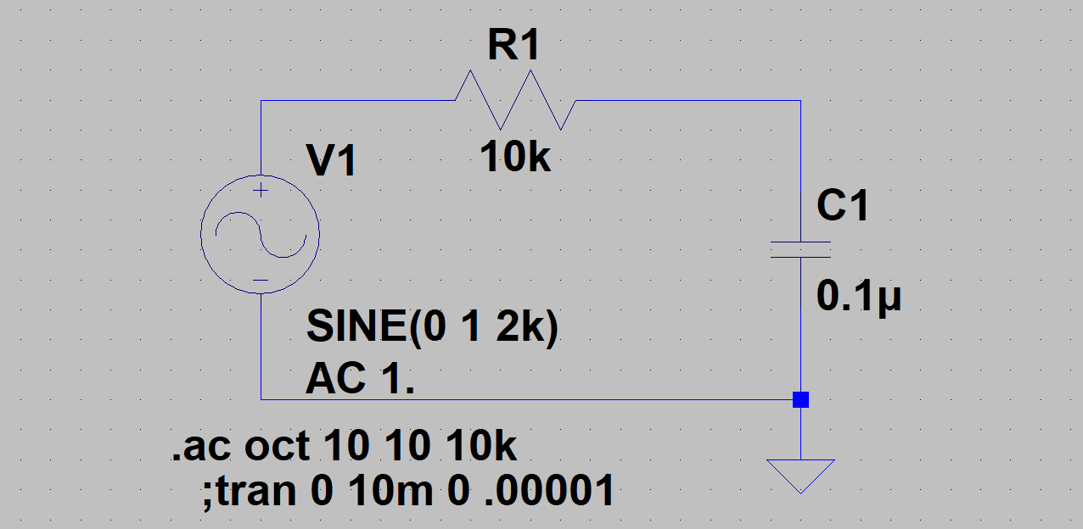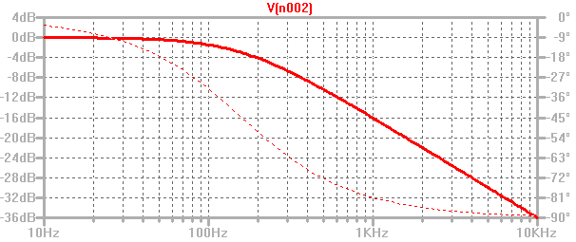
Amplitude slope is asymptotically
-6 dB /octave or -20 dB / decade
Simulated RC – Frequency sweep from 10 Hz to 10 kHz Vc Amplitude and Phase plotted (log-log graph)
Note: Decibels are a logarithmic measure of voltage ratios dB = 20*log₁₀(V_{C}/V₁) in this case. (6 db is a factor of 2, 3 dB is the “half power point”)
Analysis:
V₁ = 1*sin(2πft) = 1 at 0°, V_{C} = ?
$Z_{C}=\frac{1}{jωC}=\frac{1}{j2πfC}=\frac{-j}{2πfC}=\frac{1}{2πfC}at-90$
Our current is therefore
$I=\frac{V_{1}}{Z_{T}}=\frac{1}{\left(R-\frac{j}{2πfC}\right)}$ so
$V_{R}=R*I=\frac{R}{\left(R-\frac{j}{2πfC}\right)}=\frac{2πfRC}{\left(2πfRC-j\right)}=\frac{2πf}{\left(2πf-j/RC\right)}$ and ${ V}_{C}=1-V_{R}=1-\frac{R}{\left(R-\frac{j}{2πfC}\right)}=\frac{\left(R-\frac{j}{2πfC}\right)}{\left(R-\frac{j}{2πfC}\right)}-\frac{R}{\left(R-\frac{j}{2πfC}\right)}=\frac{-\frac{j}{2πfC}}{\left(R-\frac{j}{2πfC}\right)}=\frac{-j}{\left(2πfRC-j\right)}=\frac{1}{\left(j2πf+1/RC\right)}$
This is at the “half power point” when the magnitudes of the real and imaginary parts are equal
2πf = 1/RC (Remember that RC is the “Time Constant”) or
$f=\frac{1}{2πRC}=\frac{1}{2π{*10}^{4}*{10}^{-7}}=\frac{{10}^{3}}{2π}=159.2 Hz$ and the phase at that frequency is 45°

