Lab 4.2 – Fun with Diodes 1: Rectifiers
We are going to investigate two common uses of diodes:
- The half wave rectifier (the average voltage of the positive sinusoidal pulses – DC value)
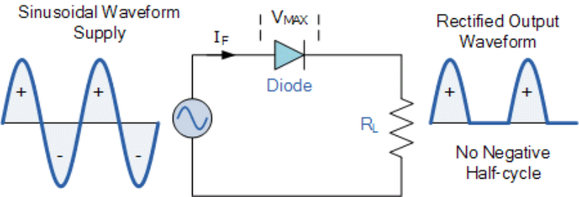
- The “Peak” rectifier that is used to do half wave AC to DC rectification in power supplies where a capacitor is added at the output and the parallel resistor simulates the “load”.
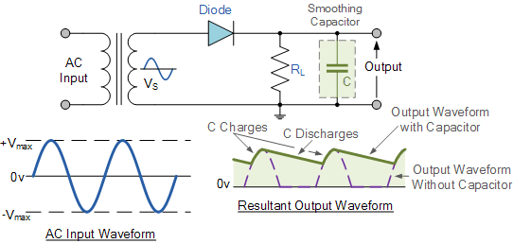
The third circuit is a sophisticated use of feedback with an OpAmp to create a “Precision Rectifier”. It is not commonly used, but you should try to understand how it works and examine it for any defects from perfection. It relies on “Feedback” an important subject that you will study after “Signals and Systems”
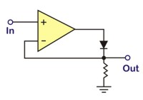
For the “half wave” rectifier, why do the output half sinusoids have a different peak value than the input sinusoid?
In the Peak Rectifier you should examine and discuss:
- The ripple – The variation in the output DC voltage each cycle.
  - Can you estimate the peak to peak ripple as a function of the frequency and the RC time constant? (set the scope to AC so that you can increase the scope sensitivity to see the ripple)
  - What does the power supply current look like per cycle? What problems can this cause?
  - Examine the first few cycles when the system is turned on (most easily done in the simulation). Why does this indicate that turning on a power supply can blow fuses?
- What is the actual DC output voltage when there is a load resistor?
Next semester you will revisit rectification when you will design and build a power supply.

