Lab 4.3 – Fun with Diodes II: Limiting and Clamping Circuits
When I was an undergraduate EE, there was a complete course called Wave Shaping Circuits (I still have that textbook in my home office). This lab investigates some of that material.
Limiters clip an incoming signal to prevent the voltage from exceeding a given value. If you severely clip a sinusoid, you get a signal that approximates a square wave.

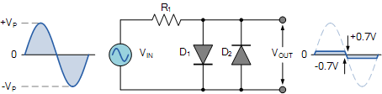
Circuit “a” – Diode limiter
Here two parallel diodes do the limiting. One clips the positive going part of the signal while the other clips the negative going part of the signal.
Note that the clipped signal has rounded transitions (why?) and that the peak of the clipped signal does have some shape (again, why?). What determines the approximate clipping level?

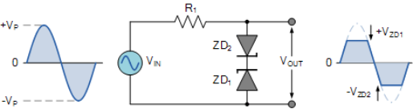
Zener Diode Clipping
Are the clipping voltages actually the Zener voltages as shown in this diagram?

First, what is a Zener diode? All diodes have a reverse breakdown voltage where the diode will conduct whatever current is necessary to stop the voltage from increasing further (note that operating a diode in breakdown destroys the diode if the power dissipation causes too high a temperature – The silicon melts). A Zener diode is designed to have a low, but controlled breakdown voltage. Two Zener diodes in series are used here for clipping (what is the actual clipping voltage? Why?). Zener diodes are also commonly used to provide a reference voltage in power supplies.

A Diode Clamping Circuit
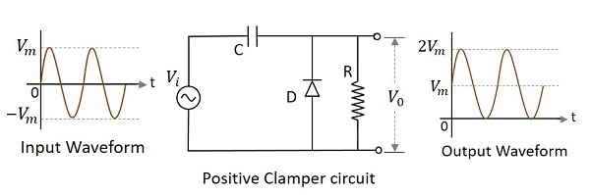
Are the negative peaks of the output signal actually at 0 volts?

Circuit “c” is a diode clamp. When the signal goes positive the diode is reverse biased. When the signal goes negative the diode starts to turn on and the capacitor charges which shifts the DC level of the output signal. After a few cycles, the clamping circuit reaches steady state and the lower peaks sit about one diode drop below 0 volts (why?). Again, try to capture and explain the transient behavior at start up (most easily done in simulation). When I was doing analog TV design, we used a diode clamp on the video signal to re-establish the “black” level of the picture by clamping the negative going peaks of the video signal.

A “Voltage Doubler”
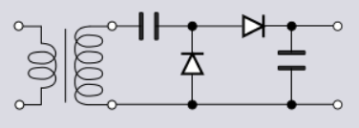
The fourth and last circuit is called a Voltage Doubler as it attempts to output a DC level that approximates twice the peak value of the incoming sine wave. The actual output is less than twice the sinusoidal peaks for two reasons (what are they?). Again, examine the transient behavior of this circuit to aid in your understanding of its operation.
