Lab 5.5 – NMOS Common Source Amplifier

What is a MosFet?
A MosFet is a simple semiconductor device. Here is a “Depletion Mode” NMOS transistor.
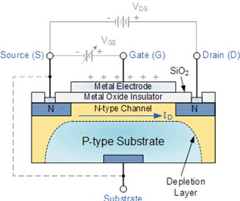
As the Gate voltage goes negative with respect to the source, the carriers in the “Channel” get pushed away and the channel gets thinner which reduces the Drain to Source current. The substrate is kept at a low voltage so that the PN junction is reverse biased to isolate the device from the substrate.
Our NMOS transistors are “Enhancement Mode” Devices:
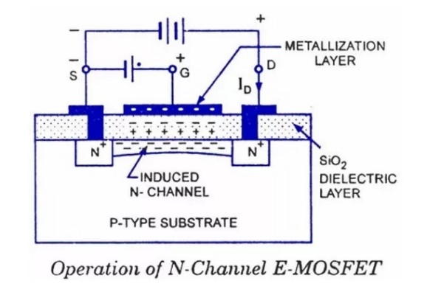
Here the gate is raised positive with respect to the source. At some “threshold” voltage level enough carriers (electrons) are attracted to the region under the gate to create a conductive “Channel”.

The Three Basic Configurations
There are three basic NMOS amplifier configurations (the word “common” relates to which terminal is maintained closest to AC ground):
- Common Source where the input is the gate voltage and the output is the Drain voltage. This is the most often used analog NMOS amplifier configuration as it can have a high voltage gain and a reasonable output impedance.
- Common Drain where the input is again the gate voltage and the output is the Source voltage. This circuit has a voltage gain that is close to unity, but the output impedance is very low.
- Common Gate where the input is the source voltage and the output is the Drain voltage. This configuration is rarer than the other two but has an advantage at high frequencies since it isolates the input circuit from the output circuit better than the other two configurations.

Transistor Circuit analysis
Note that analyzing/designing a transistor circuit has two separate steps:
- Biasing the transistor into a useful operating point (AKA the “Quiescent” or Q point) so that it is in an “active region”. For a MosFet, this is where the characteristic curves are almost horizontal (AKA “Saturation”)
- Develop the “small signal” AC model of your circuit (this ignores the DC voltages and currents)
  - Redraw the circuit shorting out all the bypass/coupling capacitors and treat the power supplies as AC ground. This is your AC model of the circuit.
  - Now replace the transistor with a suitable small signal equivalent circuit and do some simplifications. You can now do a classical AC circuit analysis on your amplifier.

Some Things to Try in This Experiment
- Measure your amplifier distortion with a distortion analyzer (Elvis and Multisim each have one). The input signal has to be at 1000 Hz as the distortion analyzer filters out the 1000 Hz signal and looks at the remaining energy in the output to determine the (total signal)/(noise plus distortion) ratio.
- Make a point of splitting the source resistor into two resistors (one small, the other large) in series and only bypass the larger resistor. This provides some negative feedback in your circuit and should allow a higher output voltage with low distortion at the cost of lower gain. Note that the gain becomes approximately the reciprocal of the percentage of feedback provided.
Many of my patents involve the use of feedback to produce circuits that have very predictable performance despite large variation in component tolerances.

