Laplace Transform Properties
There are a number of properties that can simplify taking Laplace Transforms and finding their inverse. We'll cover a few properties here and you can read about the rest in the textbook and in the Irwin Power Point Lecture notes for Chapters 13 (Laplace Transform) and 14 (Laplace Transform Applications) which cover the properties and their use in the puzzle solving that is involved in doing the Inverse Laplace Transform without resorting to doing a contour integral in the complex s-plane.

Real Time Shifting
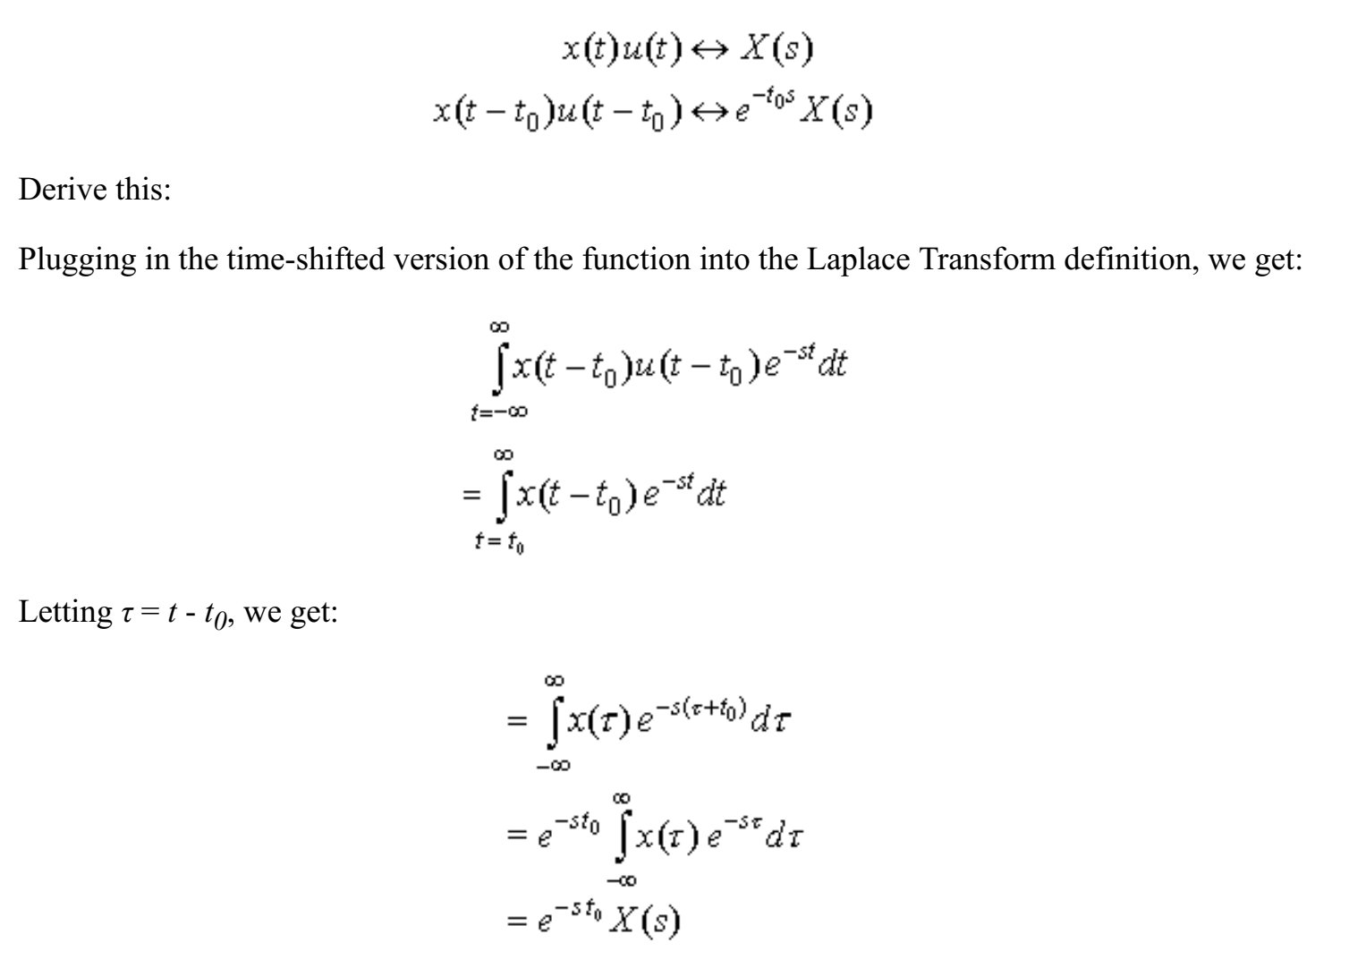

Differentiation
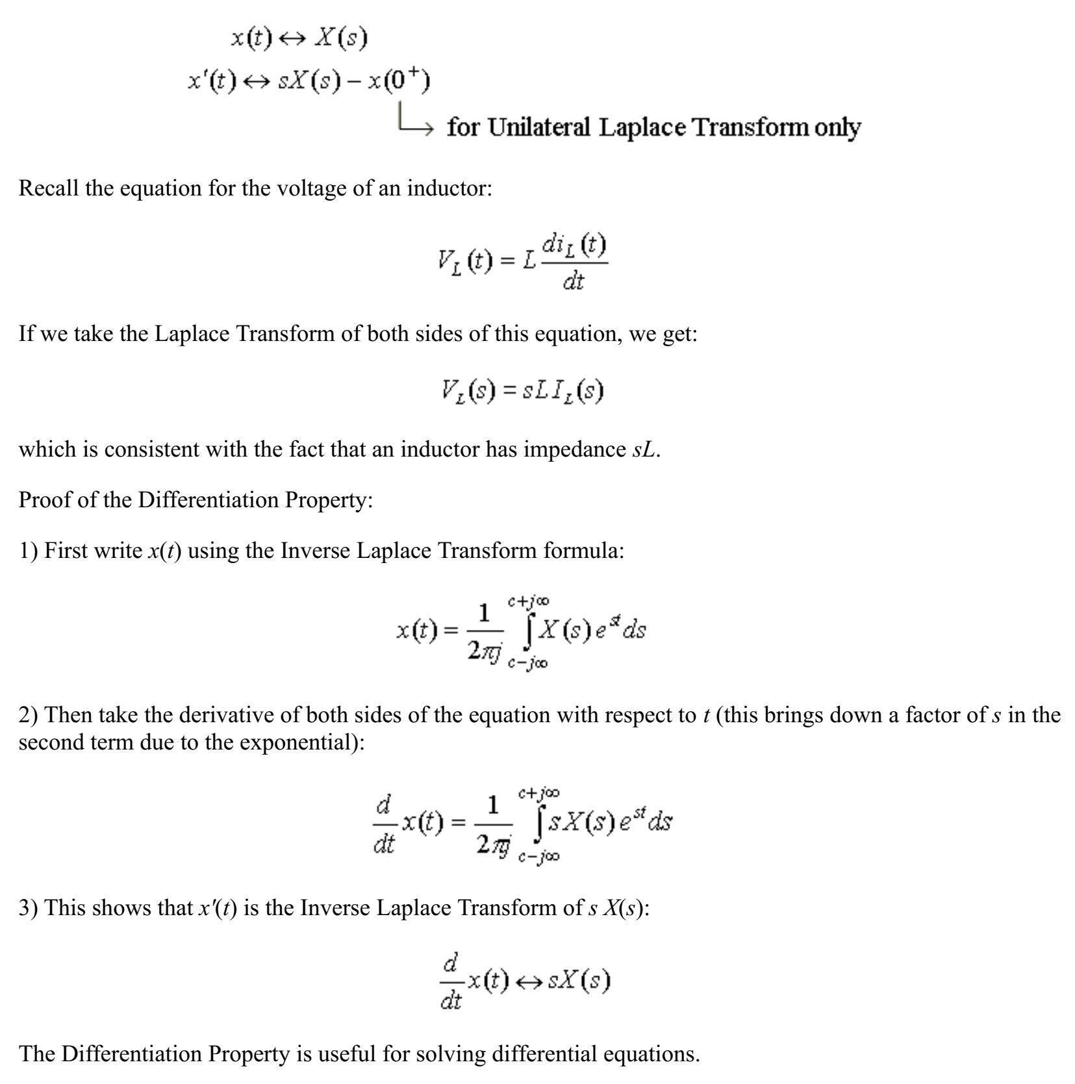

Integration
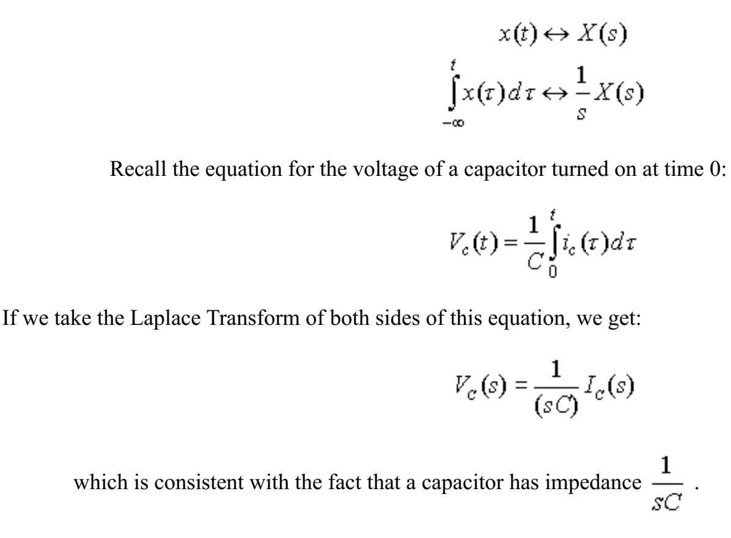

Additional Properties
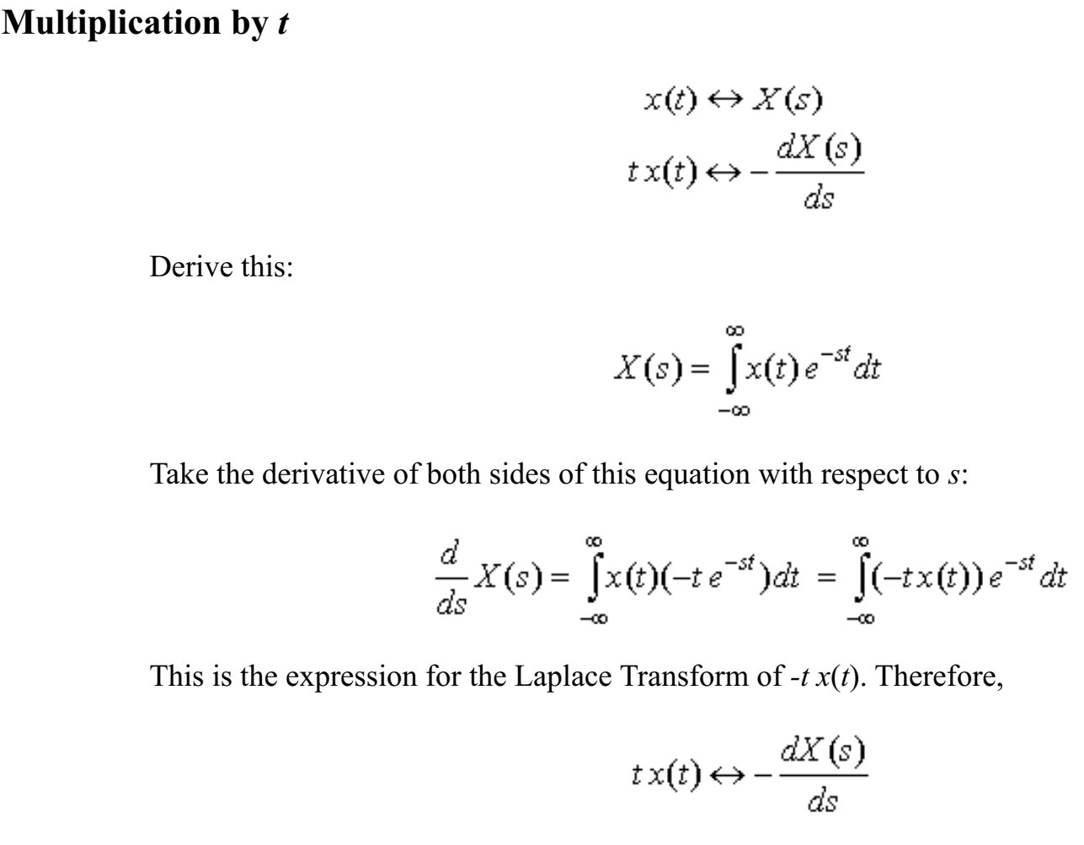

Initial Value

Final Value

Independent-Variable Transformation (for Unilateral Laplace Transform)
