Response of LTI Systems Using Laplace Transforms
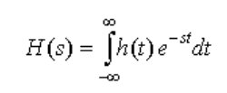

Where h(t) is an impulse response, is called the system function or transfer function and it completely characterizes the input/output relationship of an LTI system. We can use it to
determine time responses of LTI systems.

Transfer Functions
We can use Laplace Transforms to solve differential equations for systems (assuming the system is initially at rest for one-sided systems) of the form:
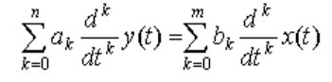

Taking the Laplace Transform of both sides of this equation and using the Differentiation Property, we get:
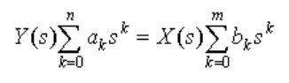

From this, we can define the transfer function, H(s), as:
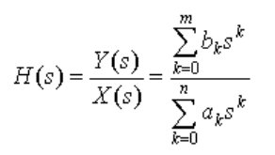

Which is the ratio of two polynomials in “s”

Partial Fraction Expansion
Instead of taking contour integrals to invert Laplace Transforms, we will use Partial Fraction Expansion. We review it here. Given a Laplace Transform,
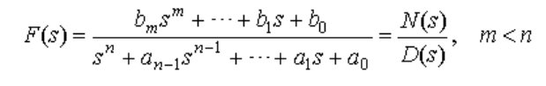
If m isn’t less than n, perform polynomial division and then the remainder can be analyzed by Partial Fraction Expansion.
We write its Partial Fraction Expansion as:
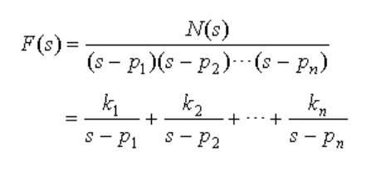
where

Assuming that all of the poles have unique values!
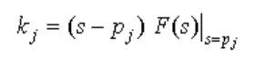

is the residue of the pole at pj.
Thus
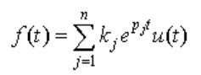

because the Inverse Laplace Transform of
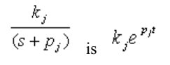

Convolution
An important property of Laplace Transforms is that the Laplace transform of the convolution of two signals is the product of their Laplace transforms:
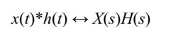

This is useful for studying LTI systems. In fact, we can completely characterize an LTI system from:
- The system differential equation or
- the system transfer function H(s) or
- the system impulse response h(t).
Example 1 Find y(t) where the transfer function H(s) and the input x(t) are given. Use Partial Fraction Expansion to find the output y(t):
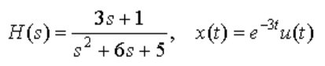

First find the Laplace transform of x(t) from a table of Laplace transforms: X(s) = 1/(s+3)

Now find the Laplace Transform of the output by multiplying H(s) by X(s)

Y(s) = (3s+1) / [ (s+3)*(s+2)*(s+3) ]

To do partial fractions we need to separate out the poles, but one of the poles is repeated so we need to find

Y(s) = A/(s+2) + B/(s+3) + C/(s+3)²

The third term is to account for the repeated root.

Multiplying both sides of the equation by (s+2) yields:

(s+2)* Y(s) = (3s+1) / [ (s+3)*(s+3) ] = A + (s+2) * [ B/(s+3) + C/(s+3)² ]

Letting s ---> -2 now yields
-5 / [ (1)*(1) ] = A so A = -5

If we now repeat the process but multiply both sides by (s+3)² we get:

(s+3)²* Y(s) = (3s+1) / [ (s+2) ] = A*(s+3)² + B*(s+3) + C

Now take the limit as s ---> -3 and

(-9 + 1) / (-1) = C so C = 8

there are two methods to find the remaining constant, B
- Take ²the derivative of both sides of the original equation and then B can be isolated by multiplying both sides by (s+3) and taking the limit as s ---> -3. This is the method shown in most textbooks.
- go back to the original equation setting A = 1 and C = 8. Then put the three terms over a common denominator and the extra terms should cancel out to leave the “B” term.
Using the second method here:

Y(s) = -5/(s+2) + 8/(s+3) + B/(s+3)

Y(s) = [-5(s+3)² + 8(s+2) + B(s+2)(s+3)] / [(s+2)(s+3)²]

Y(s) = [-5s² - 30s - 45- +8s +16 + B(s² + 5s + 6)] / [(s+2)(s+3)²]

Y(s) = (B-5)s² +(5B - 22)s + (6B-45) / [(s+2)(s+3)²]

But Y(s) = (3s+1) / [ (s+3)*(s+2)*(s+3) ] so

B-5 = 0 or B = 5 from the s² term but as a check from the s¹ term:

5B-22 = 3 OK and from the s⁰ term

6B-29 = 1 OK

We Have the partial fraction expansion of:

Y(s) = -5/(s+2) + 5/(s+3) + 8/(s+3)²

And using the Table of Laplace Transforms

y(t) = [-5*exp(-2t) +5*exp(-3t) +8t*exp(-3t)]*U(t)

Stability

We saw that a condition for bounded-input bounded-output stability was:
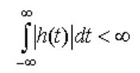

Let's look at stability from a system function standpoint.
Given a Laplace Transform H(s), we expand H(s) with Partial Fraction Expansion:
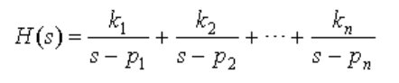

The corresponding impulse response is:

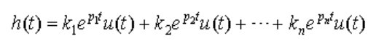

What happens to h(t) as t → ∞? For a system to be stable, its impulse response must not blow up as t → ∞.

