The Laplace Transform
In this lesson, we'll introduce our last transform, the Laplace Transform. The Laplace Transform is useful in a number of different applications:
- Using the Laplace Transform, differential equations can be solved algebraically.
- We can use pole/zero diagrams from the Laplace Transform to determine the frequency response of a system and whether or not the system is stable.
- We can transform more signals than we can with the Fourier Transform, because the Fourier Transform is a special case of the Laplace Transform.
- The Laplace Transform is used for analog circuit design.
- The Laplace Transform is used in Control Theory and Robotics

Definitions of Laplace Transform
The Bilateral Laplace Transform of a signal x(t) is defined as:
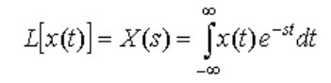

The complex variable s = σ + jω, where ω is the frequency variable of the Fourier Transform (simply set σ = 0). The Laplace Transform converges for more functions than the Fourier Transform since it could converge off of the jω axis. Here is a plot of the s-plane:
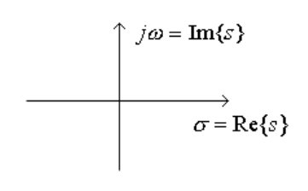

The Inverse Bilateral Laplace Transform of X(s) is:

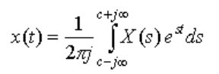

Notice that to compute the inverse Laplace Transform, it requires a contour integral. (When taking the inverse transform, the value of c for the contour integral must be in the region where the integral exists.) Fortunately, we will see more convenient ways (namely, Partial Fraction Expansion) to take the inverse transform so you are not required to know how to do contour integration.

If we define x(t) to be 0 for t < 0, this gives us the unilateral Laplace transform:
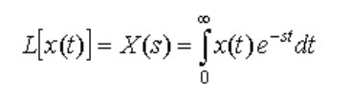

Notice that to compute the inverse Laplace Transform, it requires a contour integral. (When taking the inverse transform, the value of c for the contour integral must be in the region where the integral exists.) Fortunately, we will see more convenient ways (namely, Partial Fraction Expansion) to take the inverse transform so you are not required to know how to do contour integration.
If we define x(t) to be 0 for t < 0, this gives us the unilateral Laplace transform:

As we'll see in a later course, Signals ans Systems, an important difference between the bilateral and unilateral Laplace Transforms is that you need to specify the region of convergence (ROC) for the bilateral case.

Taking the Laplace Transform is clearly a linear operation:
L[ax1(t) + bx2(t)] = aX1(s) + bX2(s)
where X1(s) is the Laplace Transform of x1(t) and X2(s) is the Laplace Transform of x2(t).

