Finite Element Analysis (FEA) Seminar - Intro
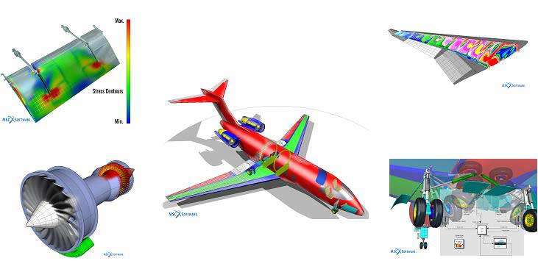

Finite Element Analysis (FEA) Seminar

- FEA is a mathematical tool to solve complicated problems in engineering and physics.

- FEA uses computer models to simulate real world problems

- To successfully use this tool, you must understand the theory, mathematics, and basic principals to apply FEA properly, know it’s limitations, and interpret results output

- For structural engineering problems with complicated geometry, loading, or materials often it is not possible to obtain an analytical, closed form solution.

- Finite element analysis essentially takes a complicated system and breaks it into an equivalent number of smaller units of which we understand the behavior. The nomenclature for this in FEA for this is discretization

- There are quite a bit more disciplines where FEA is used. (More later on this topic)

FEA Concepts

Small interconnected elements are “finite elements”. A displacement function or math representation is associated with each element. By knowing the behavior of each element individually, we can assemble all the elements and understand the behavior of the whole body.

Nodes The numerical points in space with respect to a coordinate system where we mathematically represent the intersections of finite elements

Coordinate System Cartesian x, y, and z – or –
Cylindrical r, theta, and z – or –
Spherical r, theta, and phi

Degrees of freedom The ability to move linearly or rotationally in up to six directions for each node

Compatibility A node that is common to two or more elements has the same displacements with respect to each connecting element. (Important to the displacement method of solving FEM)

The 2 key ideas of the finite element method mathematically are:

- Discretize the physical part or geometry into smaller mathematical pieces
- Use interpolating polynomials to describe the math representation of the behavior

Example Structural Problem:

Determine displacements and stresses in the structure under a static point in time where the body is in equilibrium under applied loads and reactions.

Discretize problem with finite element representation

Select element type (defines displacement behavior, strain-displacement, stress-strain, and element stiffness matrix)

Generate material and property information

Assemble all individual element information to form global equations

Set loads, boundary conditions, and constraints

Solve for global unknowns

Solve for element stresses, strains, and other desired output

Interpret and check results for sufficient design

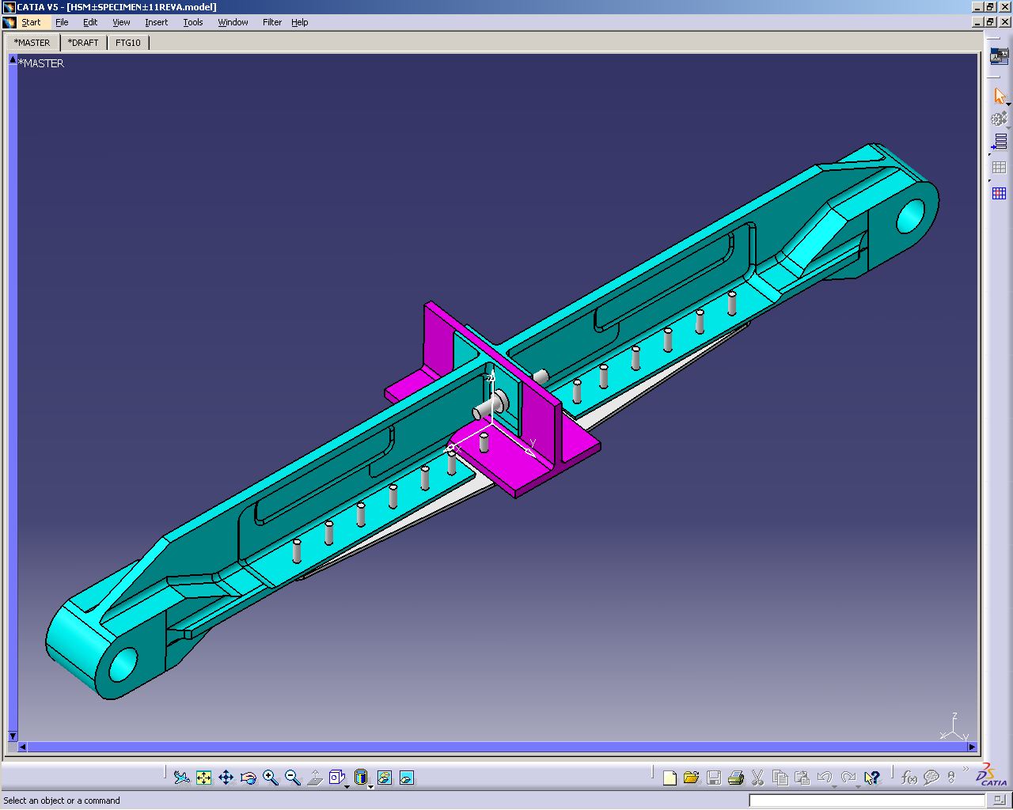
Aircraft Test Specimen Example- 3D CAD Solid Geometry
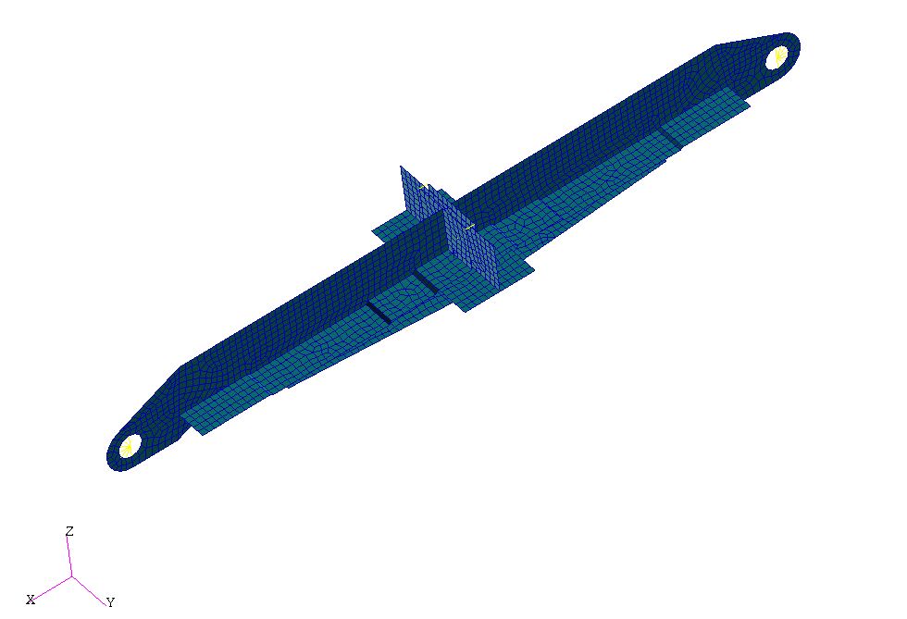
Aircraft Test Specimen Example-Finite Element Model
Aircraft Test Specimen Example-Desired Results
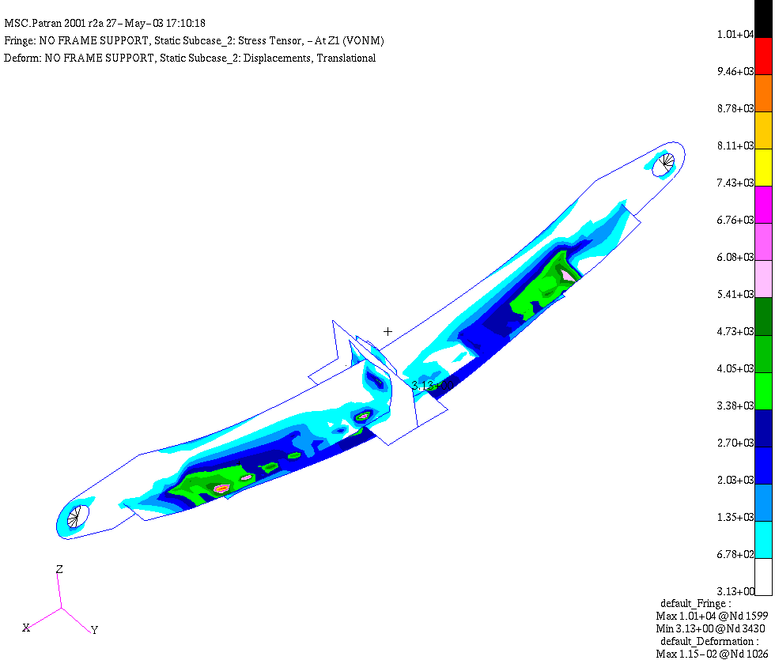

Example Element and Math Formulation

- 1-D = axial “x” direction force capability only
- Develop properties in a local coordinate system, translate to global organization
- Simple element, “prismatic” rod (constant cross-section, material)
- Linear elastic

Example Element and Math Formulation (Cont.)

Remembering Doctor D’s (Hooke’s Law, strain/displacement) After considering coordinate axes, equilibrium, and direction of loading we have,
or

Local Truss Coordinate System

Additional advantages of using FEA

- End product of FE analysis is real data used directly for design, manufacturing, and testing:
- Stresses, strains, and deformation
- Buckling thresholds
- Vibration issues
- Manufacturing pre-loads, shape, and deformation

- Model complex engineering problems: Irregular/complex part shapes, interaction, materials, or loading conditions

- Modify design easily and cheaply in the virtual world before parts are made. Saves time in the design cycle and reduces test configurations.

- Solve problems for more advanced phenomenon:
- Dynamic issues
- Non-linear geometric or material problems
- Transient and impulse conditions

Multidisciplinary Tool
- Structural Analysis
- Linear Static Stress and Deflection,
- Non-Linear Material, Non-Linear Geometric, Contact
- Eigenvalue Buckling,
- Fatigue and lifing
- Dynamic Vibration, Forced Response Vibration, Transient and Impulse Conditions
- Civil – reinforced concrete, superstructures, soil, etc…
- Heat transfer, conduction, convection, radiation, etc…
- Coupled Thermal-Structural Stress Analysis
- Implicit vs Explicit, Transient Structure-Structure interaction, Fluid Structure interaction
- Materials
- Machining, Metal forming, Metal Forging, Plastic Mold Flow
- Linear, elastoplastic, hyper-elastic, fabric, liquid, human tissue models
- Mass transport, fluid flow
- Acoustic
- ElectroMagnetic
- Advanced Mathematics
- Other disciplines?

Today’s Modern Computer Applications

- Available today on all platforms:

Mainframes, supercomputers, parallel processing
Unix workstations
NT workstations
Windows based PCs

- Pre and post-processors:

Pre-processor: graphical computer application for model creation. Generate model within or manipulate CAD data. Verify geometry, loads, properties, and materials.

Post-processor: interprets analysis results. Create deformation plots, stress/strain contour plots, element information plots.

ANSYS, MSC/PATRAN, FEMAP

- Solvers: Numerically intense computer code for finite element problem solving.

COSMOS, MSC/NASTRAN, ANSYS, ALGOR, ABACUS

