Audio Files provided as Data Files for Working with Audio Lab Assignment

- 1few.mp3: a U.S. Marines ad
- ajax.mp3: an old Ajax commercial
- always_coke.mp3: a newer Coca-Cola slogan
- ampie.mid: a midi file of Don MacLean’s American Pie
- dowahdiddy.mid: a midi file of the song Do Wah Diddy
- friends.mid: a midi file of Garth Brooks’ Friends in Low Places

<Student’s file will include a list of four additional music files that the student downloads from a music site.>

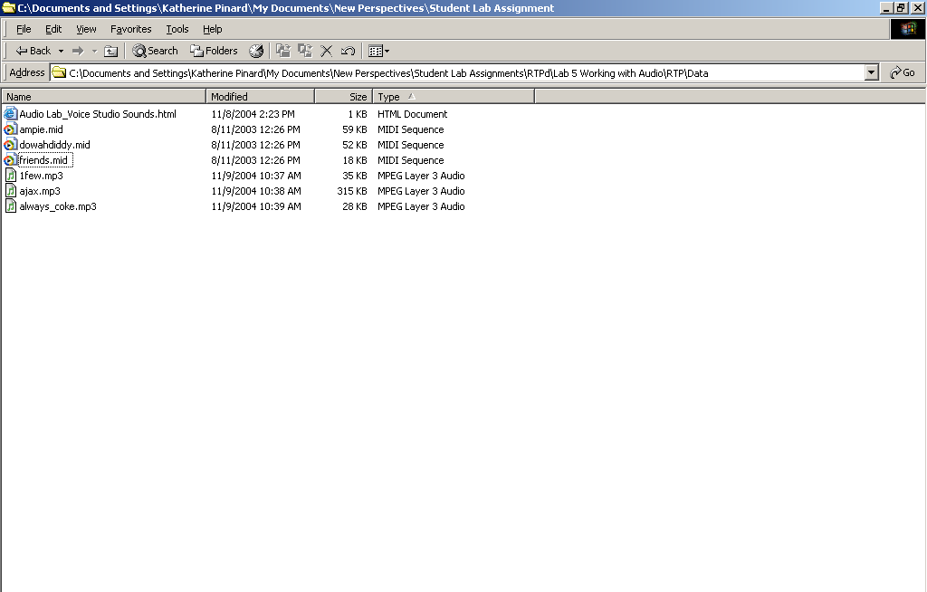
<Student’s file will include at least six additional music files and may include files from other lab assignments as well. The audio files will be grouped together by type.>

